**SUMMER INSTITUTIONAL TRAINING REPORT**

ON

**BASIC OF ANDROID APP DEVELOPMENT**

SUBMITTED IN PARTIAL FULFILLMENT OF THE REQUIREMENT FOR THE AWARD

OF THE DEGREE OF

**BACHELOR OF ENGINEERING**

(Computer Science & Engineering)



JUNE - JULY,2022

**SUBMITTED BY:**

NAME: **KISLAY KAUSHAL**

UNIVERSITY UID: **21BCS3449**

DEPARTMENT OF COMPUTER SCIENCE & ENGINEERING

CHANDIGARH UNIVERSITY GHARUAN, MOHALI

**CERTIFICATE OF COMPLETION**

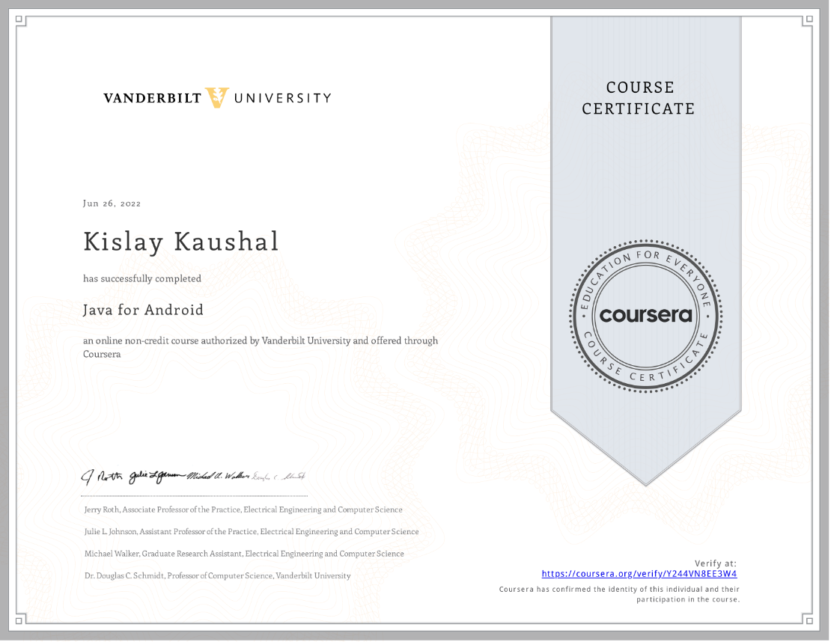

*Java For Android*

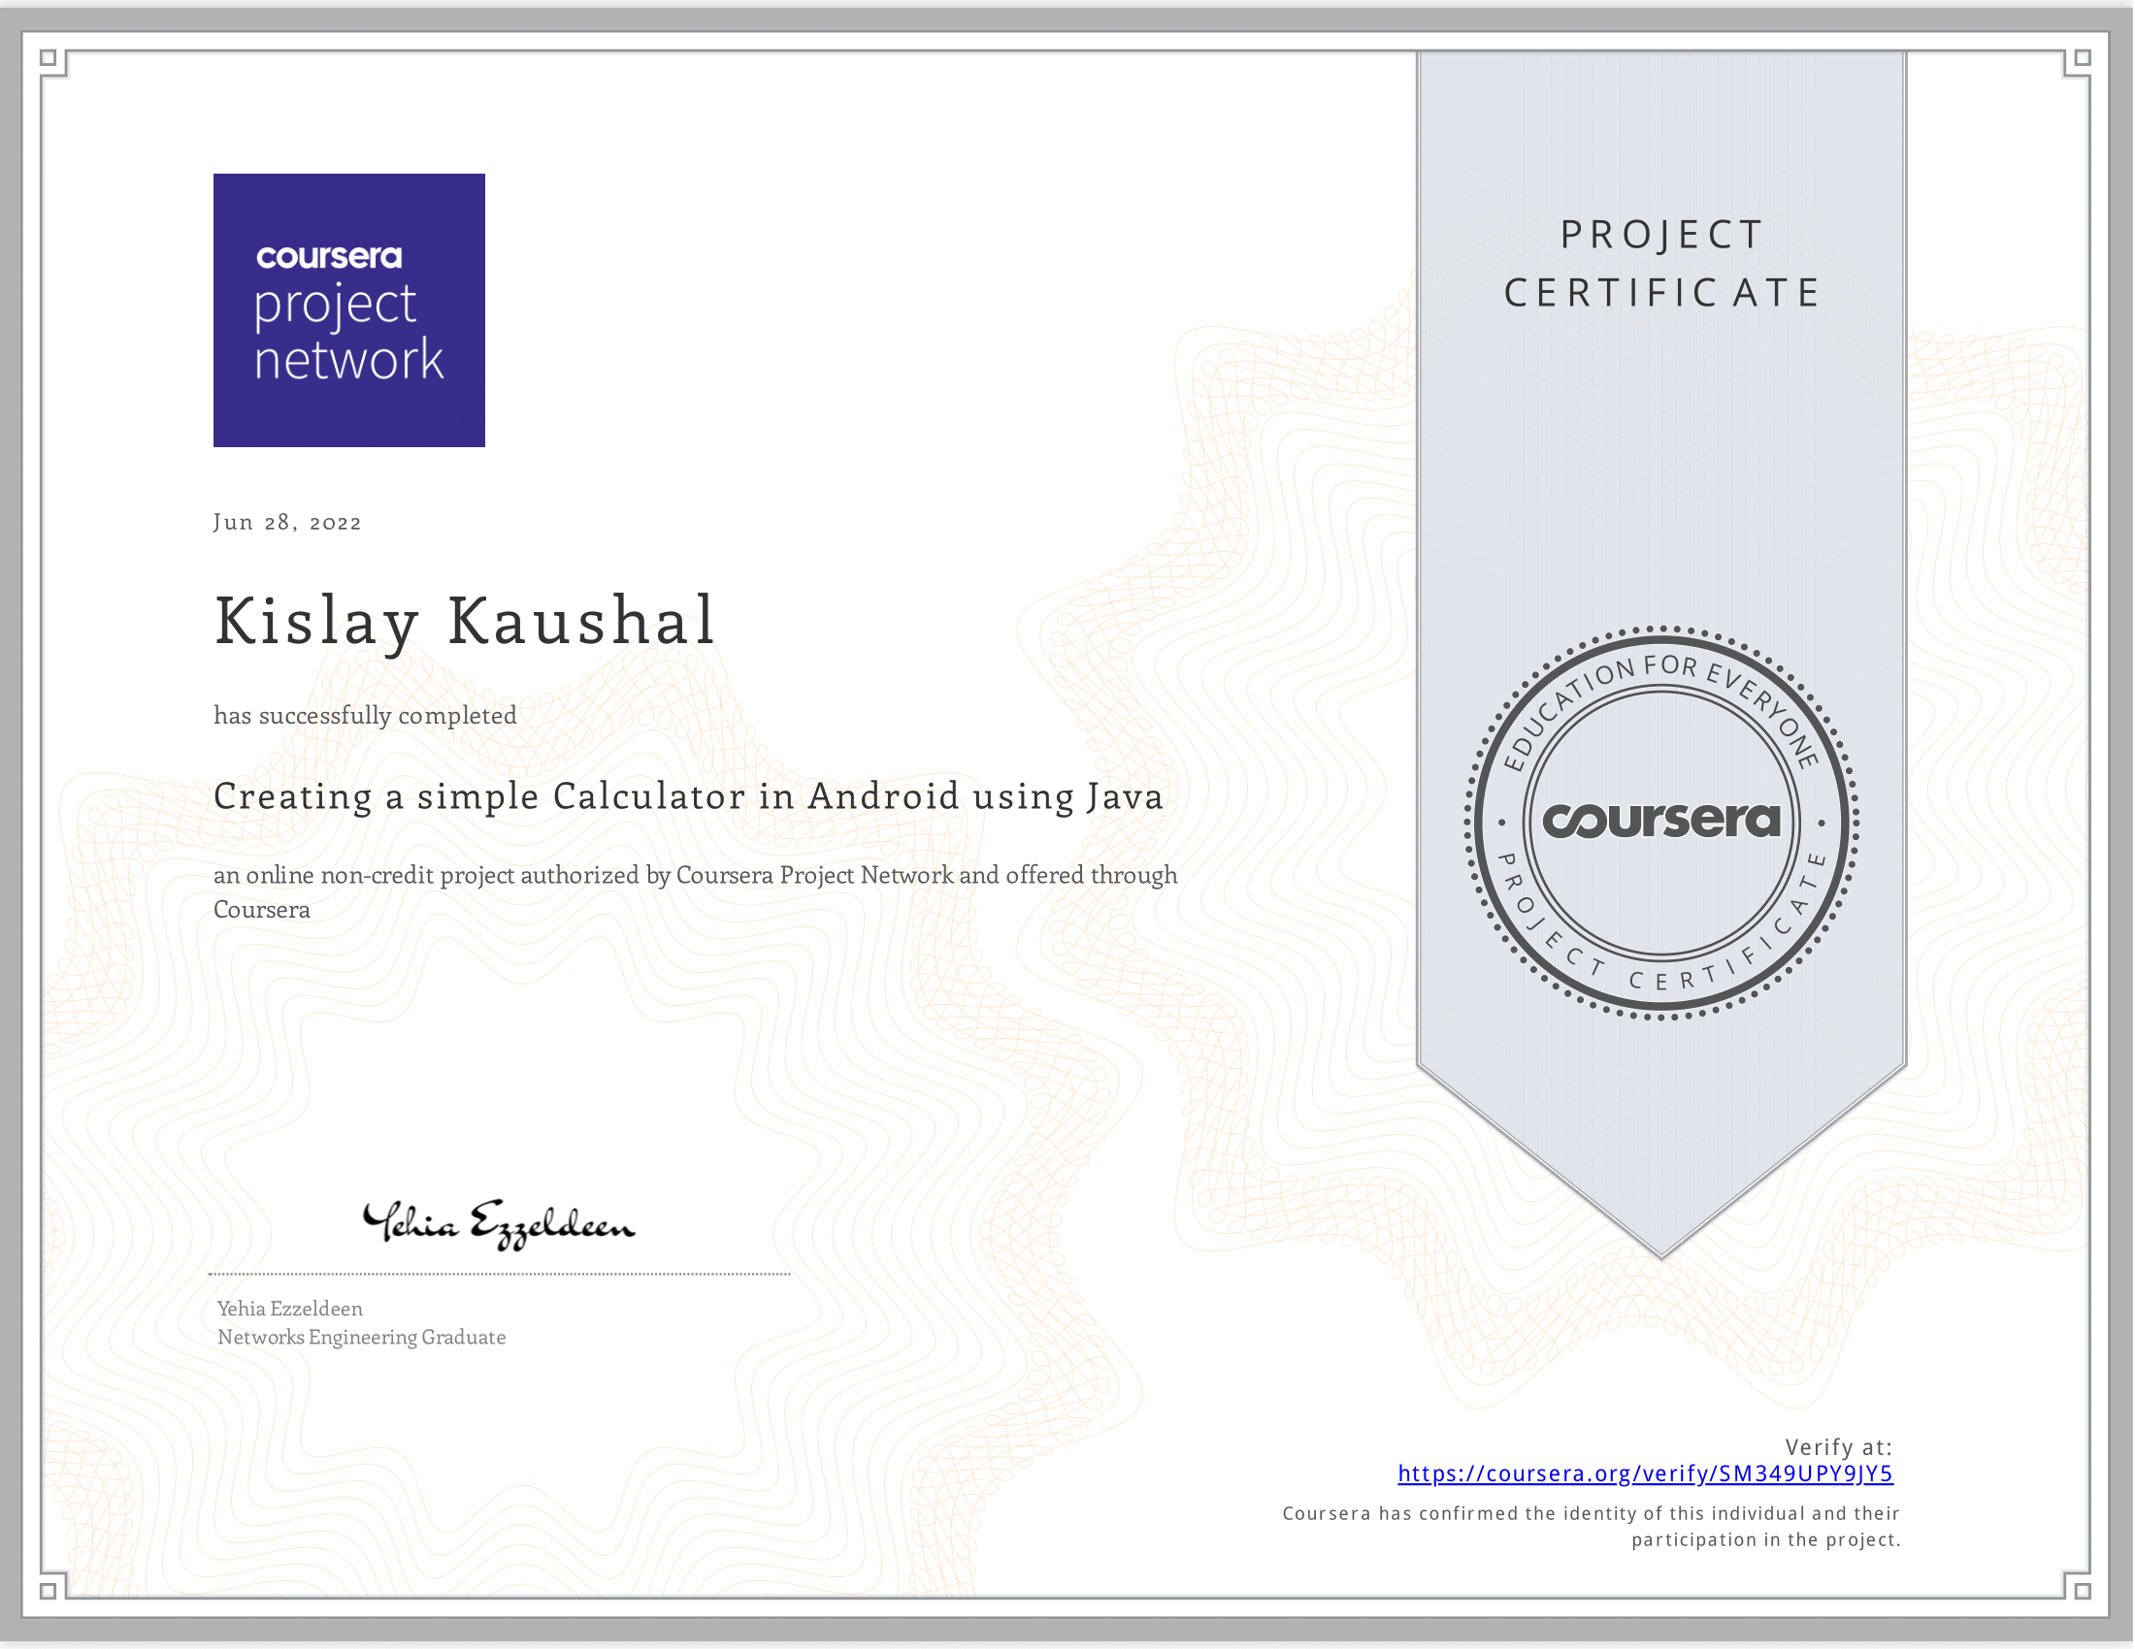

*Guided Project of Simple Calculator*

**CHANDIGARH UNIVERSITY, GHARUAN, MOHALI**

**CANDIDATE'S DECLARATION**

I Kislay Kaushal hereby declare that I have undertaken Summer Training and developed project titled “To-Do list App” during a period from 15th June to 4th July in partial fulfillment of requirements for the award of degree of B.E (COMPUTER SCIENCE & ENGINEERING) at CHANDIGARH UNIVERSITY GHARUAN, MOHALI. The work which is being presented in the training report submitted to Department of Computer Science & Engineering at CHANDIGARH UNIVERSITY GHARUAN, MOHALI is an authentic record of training work.

Signature of the Student

The training Viva–Voce Examination of__________________ has been held on ____________ and accepted.

 Signature of Internal Examiner Signature of External Examiner

**CONTENT**

**Topic**  **Page no.**

1. ***Certificates by Coursera --------------------------------------------------------------* 2**

***2. Candidate’s Declaration --------------------------------------------------------------* 3**

***3. Abstract ----------------------------------------------------------------------------------* 4**

***4. Acknowledgement ----------------------------------------------------------------------*  6**

***5. Table of Figure -------------------------------------------------------------------------* 7**

***6.Chapter 1- Introduction ---------------------------------------------------------------* 8**

***1.1 Android Programming Language --------------------------------* 8**

***1.2 Android Studio ------------------------------------------------------* 8**

***1.3 Android Studio Structure Layout --------------------------------* 9**

***7. Chapter 2- Training Work Undertaken -------------------------------------------* 10**

***2.1 Guided Project of development of Calculator -----------------* 10**

***2.2 Mini-Project (To-Do list App) ------------------------------------* 11**

***8. Chapter 3- Result and Discussion -------------------------------------------------* 12**

***3.1 Evaluation of result ------------------------------------------------* 12**

***3.2 Source Evaluation --------------------------------------------------* 13**

***3.3 Evaluation of Method ----------------------------------------------* 14**

***9. Chapter 4- Conclusion and Future Scope ----------------------------------------* 15**

***4.1 Conclusion -----------------------------------------------------------* 15**

***4.2 Future Scope --------------------------------------------------------* 15**

***Reference -----------------------------------------------------------------* 15**

**ABSTRACT**

The To-do app is a simple Android project. It allows the user to manage their day-by-day task report. This whole project has only one concept, that to record your daily task and to-do lists. Let us see what is there in the application:

1. You can add the tasks that are to be done in a descriptive way.
2. You will be able to add as many tasks as you have.
3. Once the task is completed you will be able to strike that task to make it as done task.
4. Once the task is completed, you will be able to remove it by clicking on the task for long and the task will be removed from the list.

The whole project has a simple-looking UI design. The application contains few elements on the screen like text area to input task Add button to add the task in the task view and that’s all. To develop this project of making To-do app we require Android Studio. The Application will be able to run on mobile phones and tablets having android version 5.0 and above. Here java programming language is used for the field validation and also XML language for the transferring of data. This project keeps asking you about the plugin update to keep your internet alive. And moreover, you will need to update your SDK version, and also you have to update your instant run plugins.

**ACKNOWLEGMENT**

Its gives me a great sense of pleasure to present the report of the Project “Basic of Android App development” within which I have developed a “To-Do list” App undertaken during B.E First Year. I owe special debt of gratitude to my Project Coordinator for providing me with all the necessary information and also to Department of Computer Science and Engineering, Chandigarh University Gharuan, Mohali.

At last, and not the least I would like to thank my friends who helped directly or indirectly to complete this project within limited time frame.

|  |  |  |
| --- | --- | --- |
| **Table of Figure** | | |
| Figure 1.1 | Android Studio | Page- 8 |
| Figure 1.2 | Android Studio Structure  Layout | Page- 9 |
| Figure 2.1 | Cloud Desktop | Page- 11 |
| Figure 2.2 | Calculator Icon | Page- 12 |
| Figure 2.3 | Calculator Interface | Page- 12 |
| Figure 3.1 | App User Interface | Page- 13 |
| Figure 3.2 | App working | Page- 13 |
| Figure 3.3 | Java Source Code | Page- 14 |
| Figure 3.4 | XML Source Code | Page- 14 |
| Figure 3.5 | Emulator | Page- 15 |

1. **INTRODUCTION**

Android is an operating system that is built basically for Mobile phones. It is based on the Linux Kernel and other open-source software and is developed by Google. It is used for touchscreen mobile devices such as smartphones and tablets. But nowadays these are used in Android Auto cars, TV, watches, camera, etc. It has been one of the best-selling OS for smartphones. Android OS was developed by Android Inc. which Google bought in 2005. Various applications (apps) like games, music player, camera, etc. are built for these smartphones for running on Android. Google Play store features more than 3.3 million apps. The app is developed on an application known as Android Studio. These executable apps are installed through a bundle or package called APK (Android Package Kit).

**Android Fundaments: -**

**1.1 Android Programming Languages**

In Android, basically, programming is done in two languages JAVA or C++ and XML (Extension Markup Language). Nowadays KOTLIN is also preferred. The XML file deals with the design, presentation, layouts, blueprint, etc(as a front-end) while the JAVA or KOTLIN deals with the working of buttons, variables, storing, etc (as a back-end).

* 1. **Android Studio**



*1.1 Android Studio*

Android Studio is the official integrated development environment (IDE) for Android application development. It is based on the IntelliJ IDEA, a Java integrated development environment for software, and incorporates its code editing and developer tools.

* 1. **Android Studio Structure Layout**

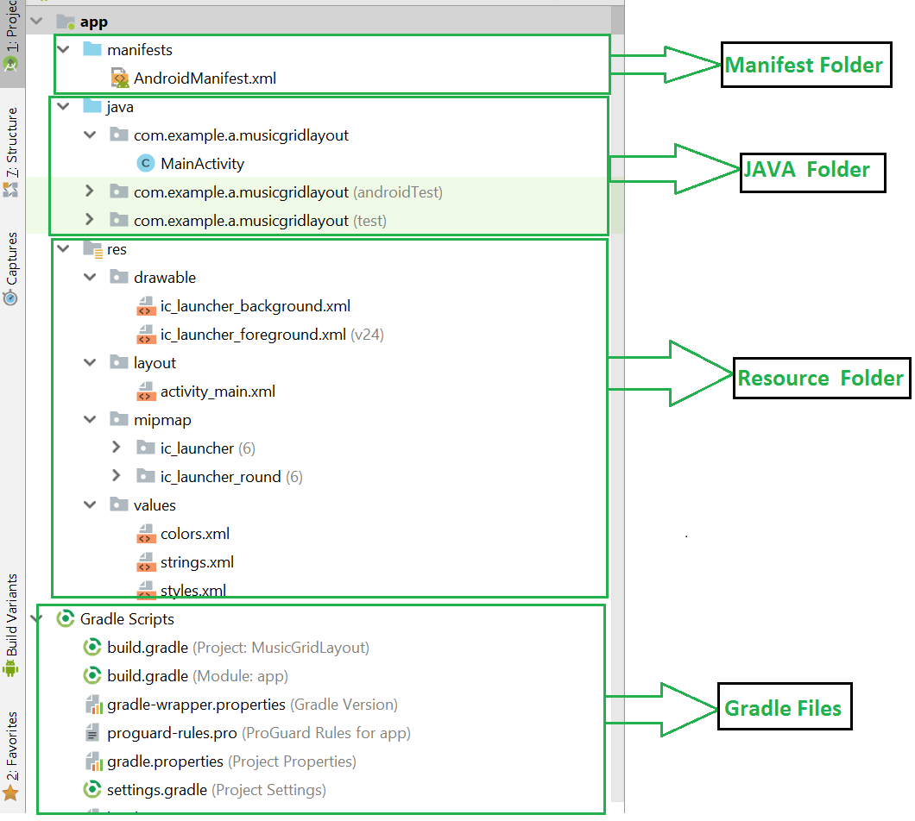

*1.2 Android Studio Structure Layout*

I. **Manifest Folder:** Android Manifest is an XML file that is the root of the project source set. It describes the essential information about the app and the Android build tools, the Android Operating System, and Google Play. In this section of Android Studio, it is easy to develop mobile app by drag and drop method.

II. **Java Folder:** The JAVA folder consists of the java files that are required to perform the background task of the app. It consists of the functionality of the buttons, calculation, storing, variables, toast (small popup message), programming function, etc. The number of these files depends upon the type of activities created.

III. **Resource Folder:** The res or Resource folder consists of the various resources that are used in the app. This consists of sub-folders like drawable, layout, mipmap, raw, and values. The drawable consists of the images. The layout consists of the XML files that define the user interface layout. These are stored in res.layout and are accessed as R.layout class. The raw consists of the Resources files like audio files or music files, etc. These res file can be accessed through R.raw.filename.

IV. **Gradle File:** Gradle is an advanced toolkit, which is used to manage the build process, that allows defining the flexible custom build configurations. Each build configuration can define its own set of code and resources while reusing the parts common to all versions of your app. The Android plugin for Gradle works with the build toolkit to provide processes and configurable settings that are specific to building and testing Android applications.

1. **TRAINING WORK UNDERTAKEN**

This course teaches us how to program core features and classes from the Java programming language that are used in Android, which is the dominant platform for developing and deploying mobile device apps.

In particular, this course covers key Java programming language features that control the flow of execution through an app (such as Java’s various looping constructs and conditional statements), enable access to structured data (such as Java's built-in arrays and common classes in the Java Collections Framework, such as ArrayList and HashMap), group related operations and data into classes and interfaces (such as Java's primitive and user-defined types, fields, methods, generic parameters, and exceptions), customize the behavior of existing classes via inheritance and polymorphism (such as subclassing and overriding virtual methods). Learners will apply these Java features in the context of core Android components (such as Activities and basic UI elements) by applying common tools (such as Android Studio) needed to develop Java programs and useful Android apps.

At the end of the course there is a guided project of development of Calculator for logical implementation of Java language and also interacted with the context of core Android component like Activates and basic UI elements that is learned in this course.

**2.1 Guided Project of Development of Calculator**

In this 1-hour long project-based course, you will learn how to (Set up a new project in Android Studio, Implement the application’s Design, Make the application responsive in Java, Run the application and add an Icon). In this particular course I learn to develop a calculator and all the development is done on a cloud desktop right in our browser, without downloading android studio or any other resources.

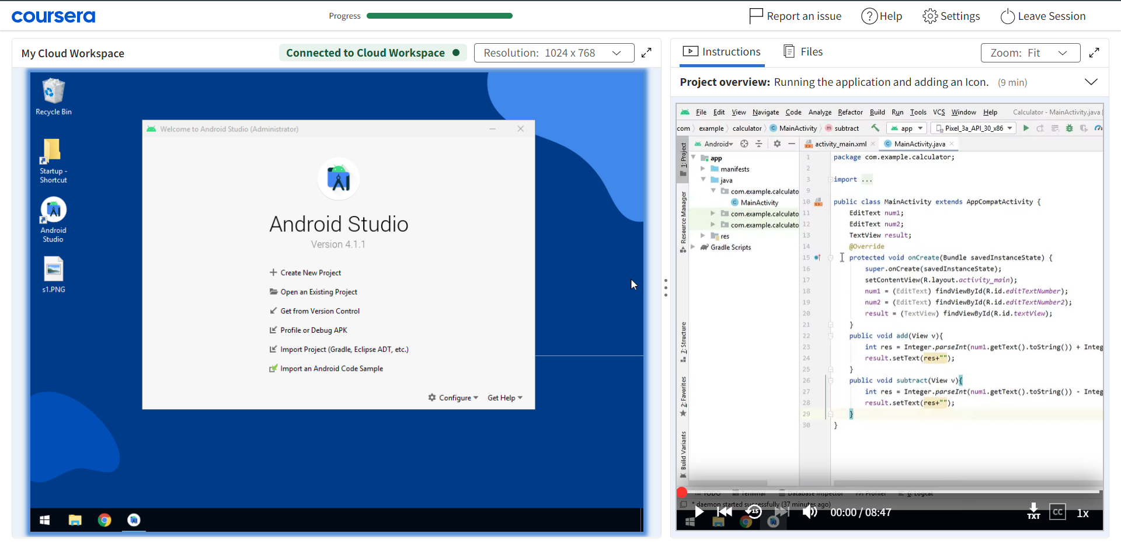

*2.1 Cloud Desktop*

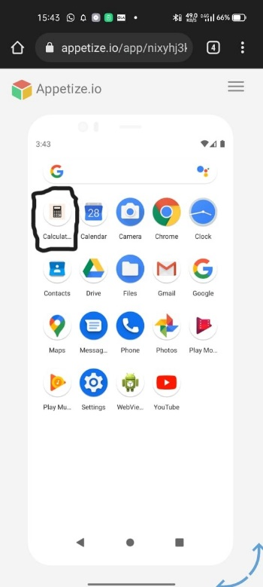 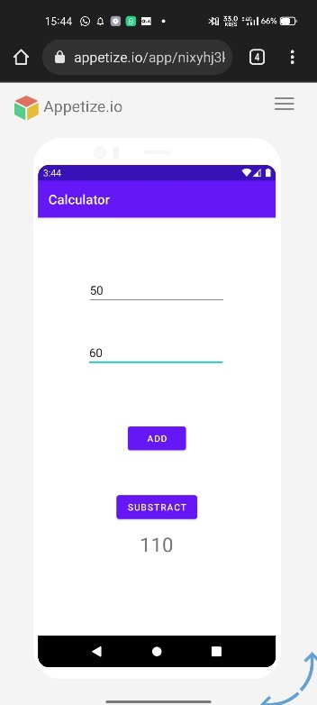

*2.2 Calculator Icon 2.3 Calculator Interface*

**2.2 MINI-PROJECT (To-Do List App)**

The course teaches us with all the necessary knowledge for the development. So, for the mini-project which is included in this summer training I have decided to develop a To-Do List application. To-Do List project is an application specially built to keep track of errands or tasks that need to be done. This application will be like a task keeper where the user would be able to enter the tasks that they need to do. Once they are done with their tasks, they can also remove them from the list. This android project helped me to practice my learnings and gain confidence in android development. All the resources that are used to develop this application are as followed: -

1. Android Studio
2. Java Language
3. XML Language

**3. RESULT AND DISCUSSION**

Our mini-project which is To-Do list application which is developed in summer training program after completion of course to test the knowledge learned. The application is ready to use and can take input of the Task from user and make it visible on the list view by clicking on the button “Add” present at the bottom of the screen. The task will be available to view in task view and also be able to strike out those task that are done and removing items from the task view by long pressing the task that you want to delete from the list.

The application is very sample and usability of this is very easy, since it does not have any complex functionality. The listing of item to removing of the item on the application is easy to perform. The only cons of the application is the it does stores information for longer period of time every time when application is launched the previous task will be deleted automatically because there is no use of Database, it is beyond our course content.

**3.1 Evaluation of result**

The Application developed is functional and it have interface which is shown below:

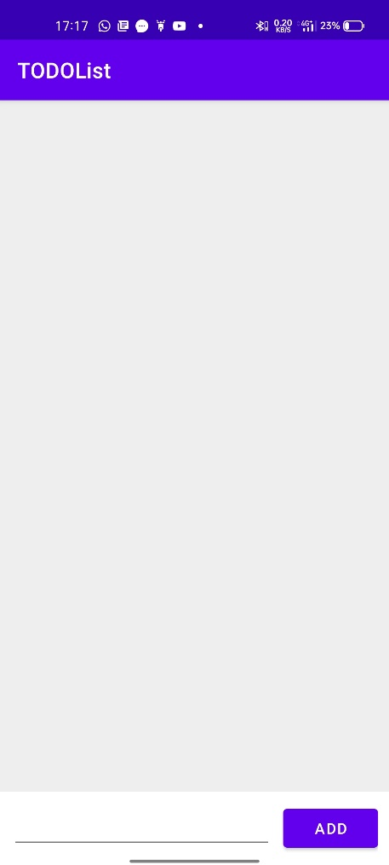 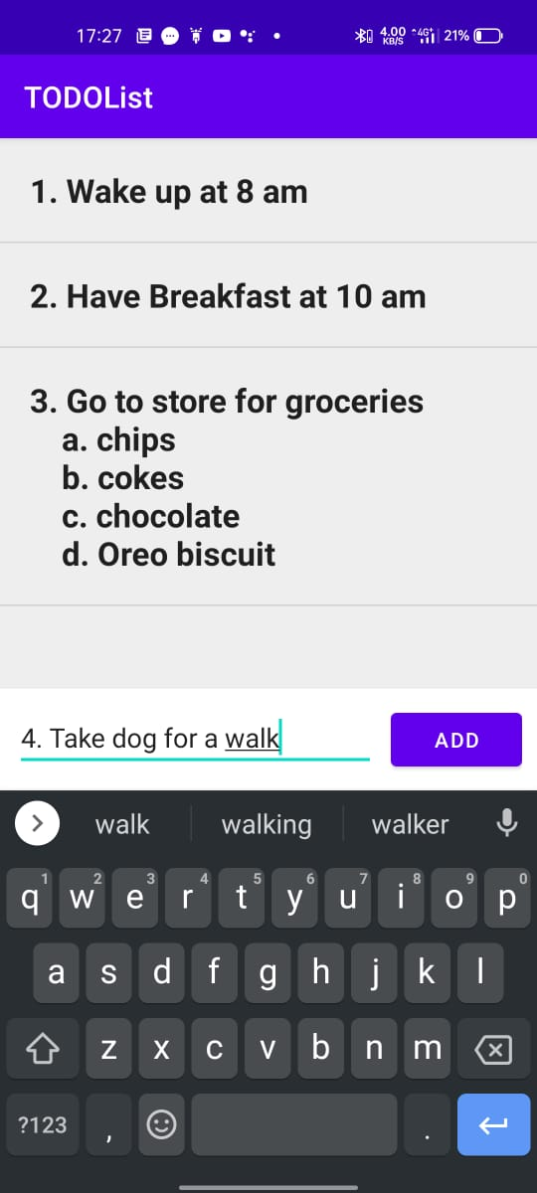

* 1. *App User Interface 3.2 App Working*

**3.2 Source evaluation**

The android development platform which is chosen for the application has lots of information and tutorials which can help us while developing the application.A lot of function that are used in this project are taken from the reference to the course content of “Java for Android” and “Creating a simple calculator in Android using Java”.

**Java Source code:**

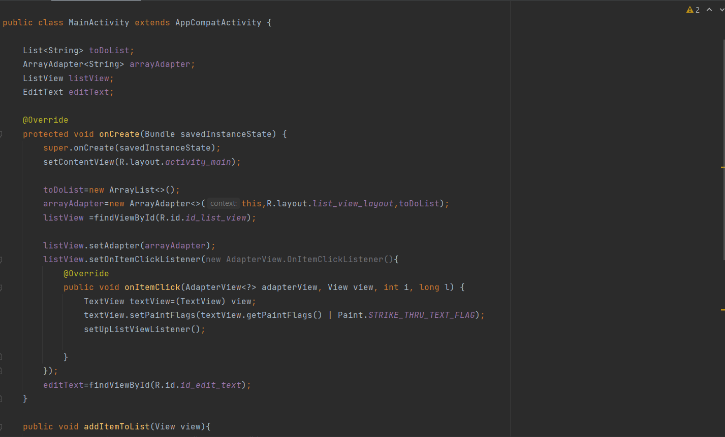

*3.3 Java Source code*

**XML (Extension markup language) Source code:**

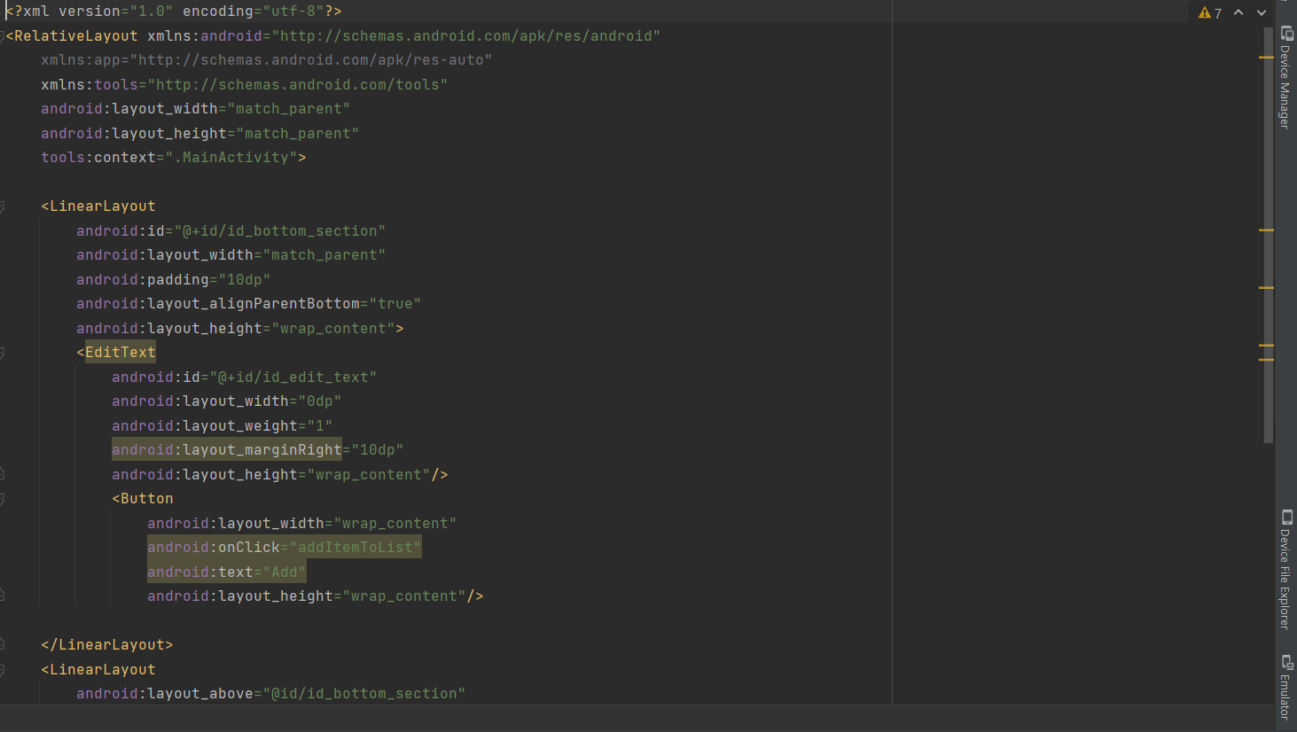

*3.4 XML source code*

**Device Manager:**

The device Manager that is used for the development of this application is Nexus 5 having API (Application Programming Interface) 30, which is also known as Android 11.

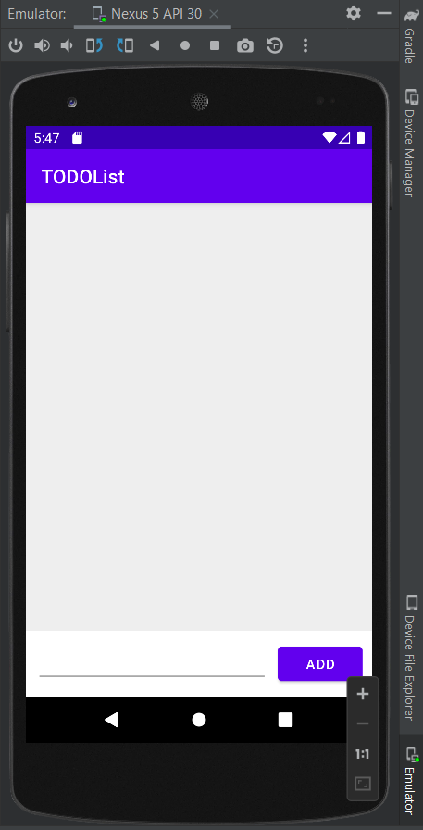

*3.5 Emulator*

**3.3 Evaluation of Method**

The Method/function that are used in this project works very useful. The main function of this application is to list items/tasks on the List view and any item/task can be removed easy from the list.

The application is tested on the Emulator as will on the Android Mobile Phone by creating Apk file of the application and downloading it on the mobile phone.

**4. CONCLUSION AND FUTURE SCOPE**

* 1. **Conclusion**

Android Smartphone are in hype in the 21th century. The scope of the android application is increasing day by day. Its development has become an essential part of today’s programming curriculum. The project To-Do List is an android app that incorporates everything from UI design to database. Its utility and efficiency is also very high. More such android app can be developed using similar concepts and tools. The society has a dearth of ideas. These ideas can be most effectively implemented by developing user-friendly android applications. Through this project, I got to learn a lot, including Data structure like ArrayList and HashMap and also I came to know a lot about developing an android application from scratch.

* 1. **Future scope**

India is one of the fastest growing nations in the world as far as IT market is concerned which foretells the propitious scope of Android App Development in India in the coming years. The scope of android app development in IT and other sectors in India can be evaluated from the fact that many of the IT industries generate their revenue majorly through their online android applications.

For Example, e-commerce industries such as Flipkart, Amazon, Snapdeal, eBay, LensKart, Jabong, Myntra etc. sell their products either through website or their android apps. Apart from e-commerce, there are several other domains which are utilizing android platform to deliver their services and products to the customers.

There is enough evidence to prove that Android Development is one of the important parts of our IT industry and somewhere it is playing the part of supporting economy of the country.

**References**

1. youtube.com
2. stackoverflow.com
3. [www.quora.com](http://www.quora.com)
4. [www.geeksforgeeks.org](http://www.geeksforgeeks.org)